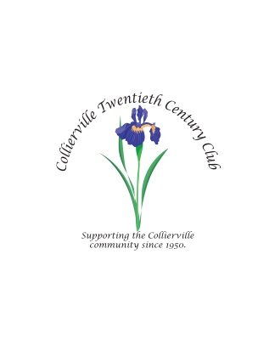
SPONSORSHIP LEVELS:
As a non-profit 501(c)(4) organization, the Collierville Twentieth Century Club relies on sponsorships and contributions to defray the costs of the annual Fair on the Square (FOS), our sole money-raising event. Individual or corporate sponsorship is an excellent way to increase the visibility of your company and show community support. Last year’s Fair was attended by more than 10,000 people, those who will see your name and logo as a sponsor.

Fair Title Sponsor (1 sponsor) $3,000.00 - AWARDED
- Name and logo of sponsor in prominent position at top of FOS poster distributed to business around Collierville
- Sponsor’s name prominently mentioned in press releases, on social media, newspapers, website, flyers, radio, and other advertising
- Sponsor’s banner or sign prominently displayed in the gazebo during the Fair
- Sponsor’s name and logo displayed at top of sponsor list displayed during the Fair
- Sponsor’s name mentioned frequently by emcee during entertainment
- Free booth or space at the Fair
- Media coverage – newspapers and online, where possible
- Platinum plated appreciation plaque.

Square Level (3 sponsors) $1,500.00
- Name and logo of sponsor on FOS poster distributed to businesses around town
- Sponsor’s name mentioned in local press releases, on social media, website, flyers, radio, and other advertising
- Sponsor’s name and logo displayed on sponsor list displayed during the Fair
- Sponsor’s name mentioned by emcee during entertainment
- Free booth or space at the Fair
- Media coverage – newspapers and online, where possible
- Gold plated appreciation plaque.

Gazebo Level $750.00
- Name and logo of sponsor at bottom of FOS poster distributed to businesses around town
- Sponsor’s name mentioned on social media and website
- Logo displayed on sponsor list displayed during the Fair
- Media coverage – newspapers and online, where possible
- Half-price booth or space during the Fair
- Silver plated appreciation plaque.

Friends of the 20th Century Club $250.00
- Name of company and logo mentioned in social media and website
- Brand logo displayed on sponsor list during Fair
- Media coverage – newspapers and online, where possible
- Certificate of appreciation.

Depot Level—In-kind donations
- Name and logo of sponsor at bottom of FOS poster
- Logo displayed on sponsor list displayed during fair
- Certificate of appreciation.

