Mary Louise Cox Twentieth Century Club Scholarship Application * 2023-2024 * $2,500
Mary Louise Cox was a charter member of the Twentieth Century Club and a life-long resident of Collierville. She dedicated herself to the club, Collierville High School, Blue Mountain College and the Town of Collierville. Ms. Cox was a long-time business teacher, Y-Teen sponsor, and band supporter.

Application Deadline – Thursday, March 25, 2024
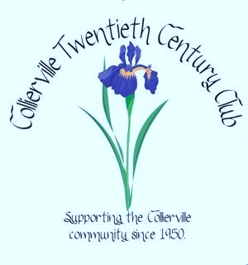
Eligibility: Please attach:
Business and technology major (Career Tech) Resume (include honors and activities)
Evidence of school and community involvement Transcript (unofficial is acceptable)
Enrolling in college/university or tech school Acceptance letter
Name: _______________________________________________________________________________
Address: _____________________________________________________________________________
City: __________________________________ State: _____________________ Zip: _______________
Home Phone: (_____) _______-_________ Cell: (_____) _______-_________
College/University/Tech School you plan to attend: ____________________________________________
Career Goal: ___________________________ Academic Avg: _____ GPA: _____ Class Rank: _______
List business concentration/classes: _______________________________________________________
_____________________________________________________________________________________
_____________________________________________________________________________________
ACT (composite): __________________ SAT (verbal): __________________ (math): _______________
Father/Guardian’s Name: ________________________________ Occupation: _____________________
Mother/Guardian’s Name: ________________________________ Occupation: _____________________
I, hereby, authorize the Twentieth Century Club to review my high school records.

___________________________________________________ ____/____/24
Student Signature Date

